April James

[jamesap@oregonstate.edu](mailto:jamesap@oregonstate.edu)

**Project #2: Zooming Helicopter**

The second CS450 graphics assignment deals with transformations, views, and motion. The objectives included:

* Importing and drawing a helicopter, correctly oriented.
* Correctly transforming and drawing two sets of blades from a display list.
* Adding an option to the context menu to change the view, and implementing different views with gluLookAt.
* Creating simple animation by editing the Animate function in the Idle Function.

Here are screenshots of my helicopter in all its glory:

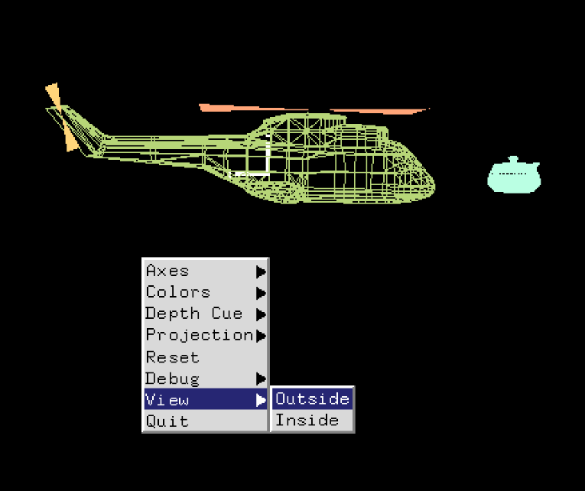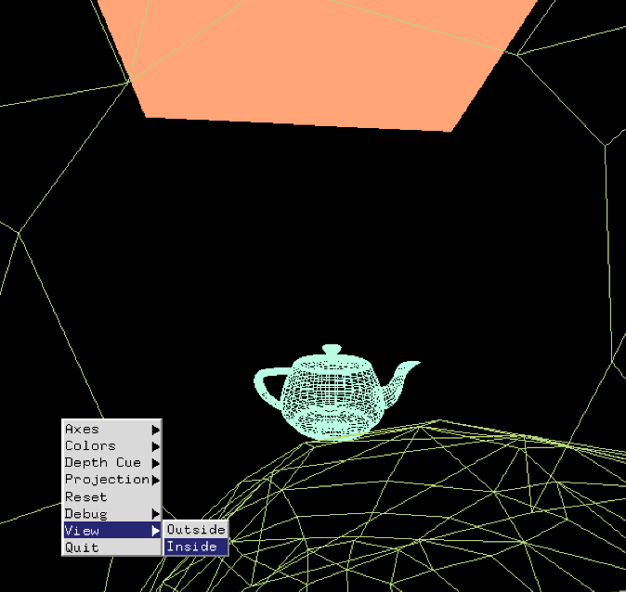

Figure : Outside View

Figure : Inside View, ft. A Blade

Here is a link to the project video: <https://youtu.be/5hVRdJfCf1w>

Thank you!